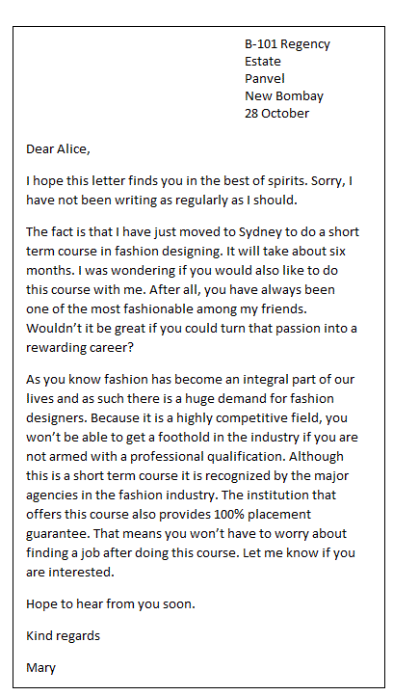**informal letter**

Hi Brand,

Thank you very much for your last letter. We haven’t seen for ages. It doesn’t matter that you haven’t written regularly, I have forgotten, too.

First things first. I’m very happy for you. It’s a good idea to visit this course in fashion designing.

Your right I’m a big fan of fashion. It’d be great if we could turn this passion into a career, but I want to study cooking at a higher federal institute. Fashion designing is a hobby I like. So I don’t want to make a career in fashion designing because I think I won’t like it.

I didn’t know that there are courses in Sydney for fashion designing. When I was a child I have already heard that only people with a professional qualification will become great and big fashion designer. But I didn’t know that you get 100% placement guarantee. That’s very interesting.

That’s all for now. See you!

Best regards

Felix